1.Pick any one app you use daily (like Zomato, Instagram, or Flipkart) and write a short problem definition for a data science project that could improve the app's user experience. Clearly state the business goal and what data you would need.
Data Science Problem Definition: Zomato
- Business Goal: Reduce customer complaints and order cancellations caused by inaccurate delivery time estimates.
- Problem Definition: Develop a machine learning regression model to dynamically predict order delivery time (ETA) more accurately than the baseline average-time model, accounting for real-time logistical constraints.
- Data Needed: Historical timestamps (order placed, cooking started, pickup, delivery), real-time delivery partner GPS coordinates, traffic density, restaurant-specific preparation time averages, and weather conditions.
2.Use the requests library in Python to fetch the latest 5 posts from the JSONPlaceholder API (https://jsonplaceholder.typicode.com/posts) and print the title of each post.<br><br><em><strong>Hint:</strong> Use requests.get() and response.json().</em>

import requests

# Fetch data from the JSONPlaceholder REST API
url = "https://jsonplaceholder.typicode.com/posts"
response = requests.get(url)

if response.status_code == 200:
posts = response.json()
# Print the title of the first 5 posts
for i, post in enumerate(posts[:5], 1):
print(f"{i}. {post['title']}")
else:
print("Failed to fetch data")

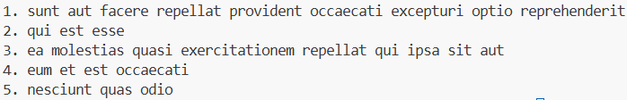

3.Given a CSV file with columns: song_name, artist, streams, and genre (simulate a mini Spotify dataset with at least 10 rows), write Python code to load the data using pandas and display the number of songs in each genre.

import pandas as pd
import io

csv_data = """song_name,artist,streams,genre
Blinding Lights,The Weeknd,3800000,Pop
Shape of You,Ed Sheeran,3500000,Pop
Starboy,The Weeknd,2900000,Pop
Bohemian Rhapsody,Queen,2200000,Rock
Hotel California,Eagles,1800000,Rock
Smells Like Teen Spirit,Nirvana,1700000,Rock
God's Plan,Drake,2400000,Hip Hop
HUMBLE.,Kendrick Lamar,1900000,Hip Hop
SICKO MODE,Travis Scott,1800000,Hip Hop
Take Five,Dave Brubeck,800000,Jazz"""

df = pd.read_csv(io.StringIO(csv_data))
genre_counts = df['genre'].value_counts()
print(genre_counts)

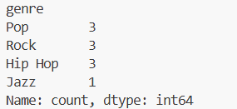

4.Create a simple bar chart using matplotlib to visualize the number of movies per genre from a dataset (you can make up a small dataset with at least 3 genres and 10 movies, like BookMyShow's movie listings).

import matplotlib.pyplot as plt

# Simulated dataset for movie listings
genres = ['Action', 'Comedy', 'Drama', 'Horror', 'Sci-Fi']
movies_count = [14, 8, 11, 4, 7]

# Create a bar chart
plt.figure(figsize=(8, 5))
plt.bar(genres, movies_count, color=['#e63946', '#f4a261', '#2a9d8f', '#264653', '#e9c46a'])

# Add labels and title
plt.xlabel('Movie Genres', fontweight='bold')
plt.ylabel('Number of Movies', fontweight='bold')
plt.title('Current Movies per Genre')

# Display the chart
plt.tight_layout()
plt.show()

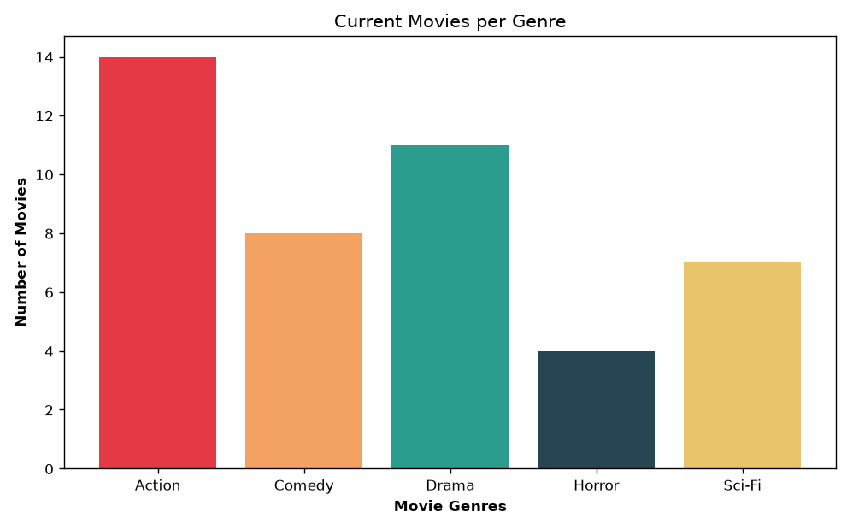

5.Use ChatGPT to suggest 3 new features that could be engineered from a dataset of online food orders (like Zomato orders: order time, restaurant, cuisine, delivery time, rating). List the features and explain how each could help a data science model.<br><br><em><strong>Hint:</strong> Paste the column names into ChatGPT and ask for feature engineering ideas.</em>

Food Delivery Dataset
- Total Fulfillment Duration (Numeric): delivery time minus order time.
  - How it helps: A raw timestamp is difficult for models to interpret. Converting it into a total duration (in minutes) provides a continuous numeric feature that heavily correlates with food temperature and user satisfaction, helping a model accurately predict the final rating.
- Peak Hour Flag (Binary): A flag (1 or 0) indicating whether the order time falls during standard local rush hours (e.g., 12:00 PM–2:00 PM or 7:00 PM–9:00 PM).
  - How it helps: Rush hours strain restaurant kitchens and delivery partner availability. This categorical feature helps a model account for systematic delays or lower ratings that happen exclusively during high-volume periods.
- Cuisine-to-Restaurant Match (Categorical): A feature checking if the ordered cuisine matches the primary category/tag of that restaurant (e.g., ordering a burger from a sushi restaurant).
  - How it helps: Restaurants cooking secondary cuisines might have slower prep times or lower quality. This helps a predictive rating model identify mismatches between a restaurant's core competency and what was actually ordered.

